Project – Report
1a. Which campaign generated the highest number of impressions, clicks, and conversions?
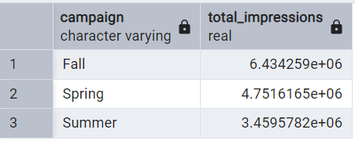
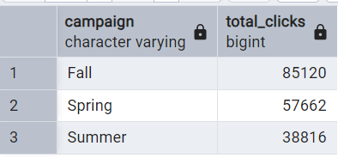
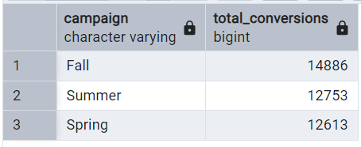
1b. What is the average cost-per-click (CPC) and click-through rate (CTR) for each campaign?
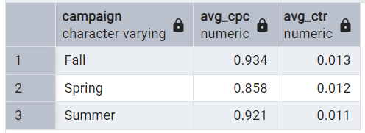

2a. Which channel has the highest ROI?
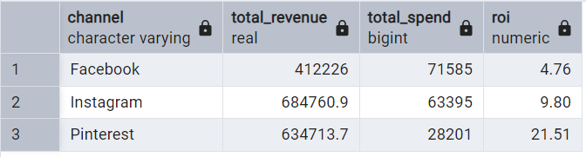
2b. How do impressions, clicks, and conversions vary across different channels?
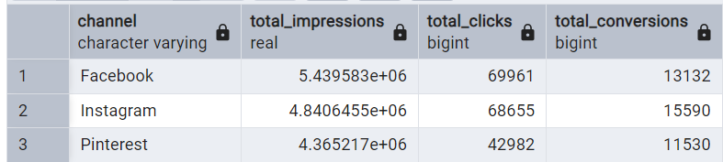

3a. Which cities have the highest engagement rates (likes, shares, comments)?
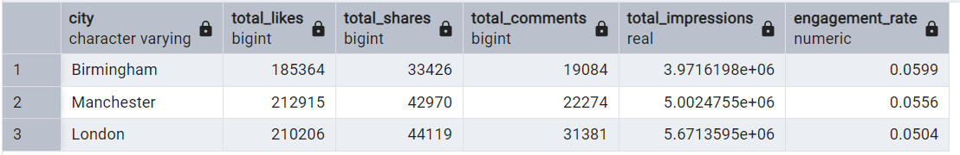
3b. What is the conversion rate by city?
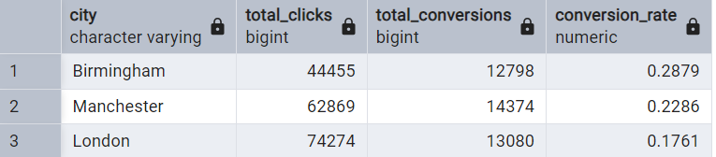
4a. How do ad performances compare across different devices (mobile, desktop)?
4b. Which device type generates the highest conversion rates?
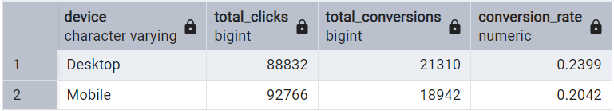
5a. Which specific ads are performing best in terms of engagement and conversions?

5b. What are the common characteristics of high-performing ads?
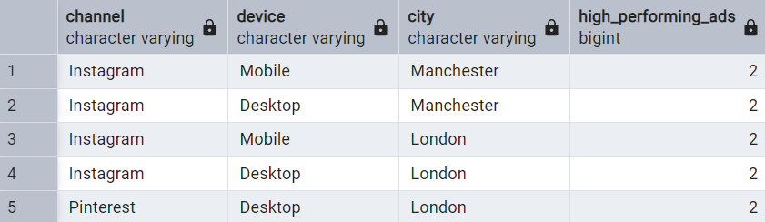
6a. What is the ROI for each campaign, and how does it compare across different channels and devices?
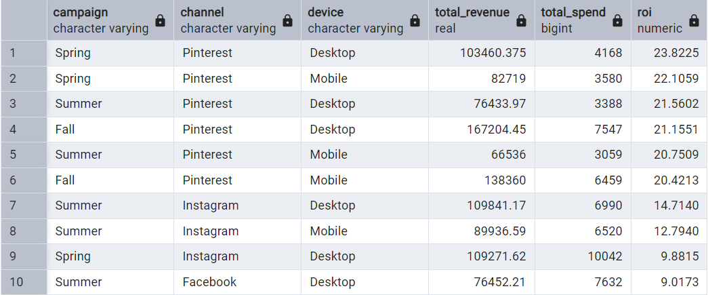
6b. How does spend correlate with conversion value across different campaigns?
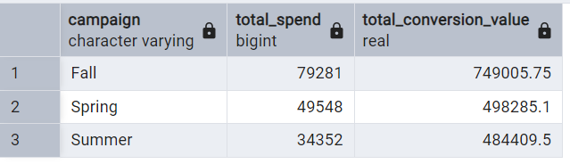

7. Are there any noticeable trends or seasonal effects in ad performance over time?
